

# Programming Languages Project: Final Report

## Luis Alfredo Rodriguez Santos

A01701260 – 08/11/2018

Contents

Programming Languages Project: Final Report 1

Context of the Problem 2

Proposed Solution 3

Solution Architecture 4

Threads 4

Multithreading 4

Concurrent 5

Parallel 5

Java Classes 6

Results 6

Paradigm Analysis 6

Conclusions 7

Setup Instructions 7

Evidence 8

References 9

# Context of the Problem

The food industry is evolving trying to diversify their products, there are many products that don’t make it to the market because of different reasons. The food industry market is currently growing at a 5% annually and it is estimated that because of consumism, population growth and other factors this number will increase.

Crunching the numbers to calculate the viability of a products can be sometimes ambiguous also it requires the knowledge of some aspects that can affect the production value. As personal experience has taught me there are some numbers that have to be exact for the outcome to have relevance and prove the point you are making. In this case I own currently part of a company that produces precooked products and constantly look for new products. To calculate the viability of a product we first need to see what the cost of a single bag would be, and that includes the raw material, personnel, and time.

# Proposed Solution

In response to the problem I came up with a solution that automatically can calculate the main values someone would need to verify the viability of the product. Also, you can use it to calculate the time of labor hours, costs, profits and time of fabrication of the product you currently are producing. The usefulness of making this calculation of different products simultaneously helps in rapid decisions to choose in which product will be more viable.

The reason for people to choose my solution is because of the simplicity to calculate the values with just entering the amount of the product you want to produce and the amount of personnel you would use for production. These values are calculated with default variables that are already set in the program like the basic salary of the staff and the cost of services.



There are other tools that can accomplish the same calculations the only difference is the time it will take to calibrate these to get the result you want. On the other hand, what people need is in this case an approximation to the real value for quick decisions. An excel sheet would take for the entering of the values as well as the required equations to get the desired values.

# Resultado de imagen para parallel threads in javaSolution Architecture

The solution implements threads in java that are run parallel to each other to calculate the respective values of a class product. This makes the program get the results faster by the method of multithreading, dividing the tasks.

## Threads

A thread is used to execute small sequence of instructions these instructions can be interrupted or synchronized to complete their task. They can be started simultaneously to complete different task at the same time or they are used to divide big tasks into smaller ones. There are different ways to use threads they can be concurrent or parallel, what makes these methods different is the use of resources, memory and time it takes to complete their task.

Java makes the use of threads simpler by offering a library with methods to handle threads, the way threads exist in java is in different states such as:

* New – Create a new instance of thread class.
* Running – Thread runs.
* Suspended – A running thread is suspended (sleep) temporarily.
* Blocked – The thread becomes blocked when waits for resources.
* Terminated – A thread is terminated when the execution completes the task.

## Multithreading

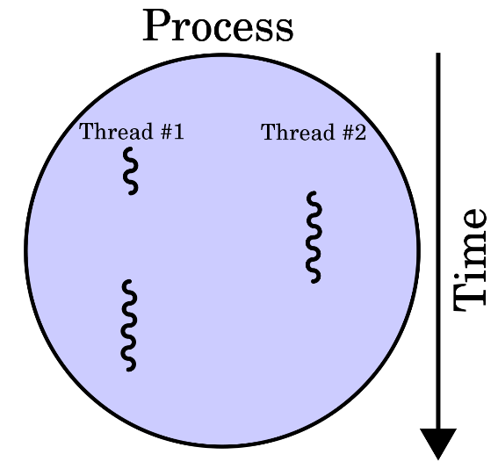

Threads can be used independently to complete task sequentially but when you use more than one thread to complete a process it becomes multithreading. When multithreading the resources are shared by each thread and the execution time reduces because of the brake down of the process. Resources may be idle when using a single thread so by using various at the same time It takes advantage of those idle resources.

There are some methods implemented in java that may help with threads in general to keep control of how they are running.

**Method**

* Join() – Waits for other threads to terminate.
* Run() – Entry point for the thread
* Sleep() – Pause a thread for a specific time period.
* Start() – Start a thread by calling the run method

Still there are precautions to be taken when using threads because they can become unsynchronized an end up blocking each other. Also, other threads can keep going if there is no response from another thread that has finished its process, that’s why there are some helpful functions that can prevent situations as the ones mentioned.

### Concurrent

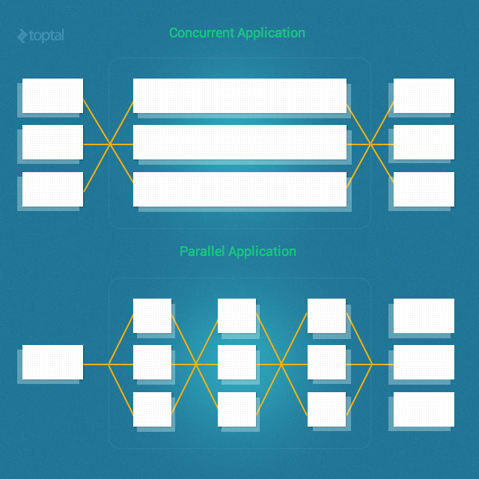 When threads are executed concurrently they preform different tasks that will return different outcomes therefore they don’t need necessary to start at the same time but they can run simultaneously in the end asynchronous threads. They still share the same resources but don’t depend of each other to perform the process as image shows.

### Resultado de imagen para multithreading parallelParallel

Parallel threads is a more efficient manner to handle a process, in this case the threads are running at the same time breaking a single task to return a single variable. Because it divides the process and works at the same time on a single task this method is faster than concurrency. Non the less if not implemented correctly it would block its self. An example is shown on the image on the right.

## Java Classes

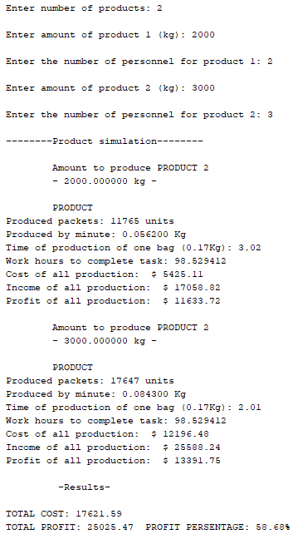

In the solution we created a certain object in a class, meaning that the class basically is a blueprint to create the object that is going to be used in the main program. This blueprint contains al the properties and the behaviors of the class which are at the same time coded into methods that can be called by other classes or the main program.

The implementation of the classes made it easier to create objects for each thread independently that together would use methods define to calculate values of each product, as well as, interpret the viability of each of the products and the total cost and profit of all the product created.

# Results

The results of the test made showed that the program has no error in the calculation of the numbers and the performance speed is outstanding when creating more than 20 products. The people who helped with the tests for the most part were industrial engineers

There were stress tests to create more than 122 different products and the results were printed in less than 20 seconds. Also, the information that it gave back was useful for some of the people that used the program to get some light in their product ideas.

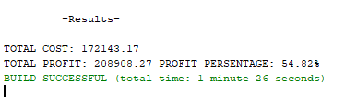More test were preformed but it seems that currently we haven’t found a amount of products that would delay the calculations more than 2 minutes. Still there are limitations to the calculations made because of the hardware used to run the program.

# Paradigm Analysis

To accomplish this solution, it was necessary to implement multithreading in the creation of each product and make them parallel to calculate the total of costs and profits. Using threads simplified each calculation and made it for the idle resources of the CPU to be used. Also, by using the method join it was possible to wait for all the threads to terminate at the same time and calculate the total cost and profit made with all the products together.

Because java is an object-oriented programing language it was possible to combine the threads to each of the products and separate the calculation tasks. Every method used inside the object had distinct outcomes because of the values assigned to them. In the end it made it easier to get approximates that demonstrated the viability of the product.

# Conclusions

During the process of completing the project there was investigation done to find out precise information of production values. There are excel sheets and text documents that backup all the method of calculations used in the coding. The challenging part to complete the project was to make the research of how much it takes in time and resources to create a single package of a product and take those numbers to return the most important values.

Working in java with threads facilitated most of the work because of the to create an object for each tread. As an object-oriented programing language, Java also included the aspect to create various methods inside the class this made it easy to display the values for each of the threads.

What we learned in class helped on the development and contributed to the further learning of the threads and how to run them sequentially, concurrently and in parallel. Although it we had implemented similar problems in labs made previously, when developing a program of your own contributes to the understanding more than assigned work. In my opinion the comprehension of how to code in java threads easier and it doesn’t take to much time to code. Multithreading has become more simple with the implemented methods la join() that assures that all the threads wait until they are terminated.

For further development of this program I will integrate more fields of calculations that can show even more how a product would be viable in the market. It will be tested with the company to improve the performance and the accuracy of the values given, as well as, include a friendlier interface that can be executable an doesn’t require compilation an running in the terminal shell.

# Setup Instructions

In order to run the program, you will need to follow some steps. For the program to run it is needed to have java installed in your computer you can find the download link [here](https://www.oracle.com/technetwork/java/javase/downloads/jre8-downloads-2133155.html).

**Steps**:

1. Clone the repository from GitHub with:

git clone <https://github.com/Luisalfredrod/Leng_de_Prog>

1. Open a CMD prompt and verify that you have java installed:

java –version

1. Go to the SCR directory and compile the java files with the command:

javac filename

1. Finally, to run the program use the following command:

java Project

# Evidence

The evidence of the project is available in the following GitHub repository:

* <https://github.com/Luisalfredrod/Leng_de_Prog>

This repository includes the code, a client binary and the README and LICENSE files. The project is licensed under de GNU General Public License v3 that include the following permissions.



# References

1. Jankov, J. (2017). Java Concurrency and Multithreading Tutorial. Retrieved from <http://tutorials.jenkov.com/java-concurrency/index.html>
2. Java Classes and Objects | Wideskills. (2018). Retrieved from <http://www.wideskills.com/java-tutorial/java-classes-and-objects>
3. Lavey, E. (2018). *Parallel Threads Tutorial* [Ebook]. Retrieved from <https://ptolemy.berkeley.edu/eecs20/labs/LabVIEW_Tutorials_PDF/HowParallelThreadsWorkTutorial.pdf>
4. Rivera, J. (2018). Growing Futures: Food Industry. Retrieved from <https://www.plantandfood.co.nz/growingfutures/food>
5. Tuli, S. (2018). Java Thread Tutorial: Creating Threads and Multithreading in Java - DZone Java. Retrieved from <https://dzone.com/articles/java-thread-tutorial-creating-threads-and-multithr>